**IOT BASED NOISE POLLUTION MONITORING**

A project report submitted in partial fulfillment of the requirements for the degree of B.E computer science engineering

By

D.DEEPIKA-513221104303

Under the supervision of professor and HOD department B.E computer science engineering

**NOISE POLLUTION MONITORING**

**PROBLEM DEFENITION AND DESIGN**

**THINKING**

**✓ PROBLEM STATEMENT**

**✓ DESIGN THINKING APPROACH**

**Technical innovation ideas for noise pollution**

1. Noise barriers or sound walls
2. Noise reducing road surfaces
3. Lower speeds
4. Electric vehicles
5. Vegetation surrounding roads

**Department of noise pollution monitoring**

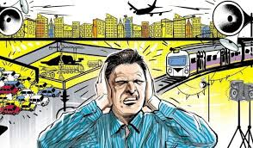

Noise pollution impacts millions of people on a daily basis. The most common health problem

it causes is Noise Induced Hearing Loss (NIHL).Exposure to loud noise can also cause highblood pressure, heart disease, sleepdisturbances, and stress.Noise pollution is caused by extremely loudsounds and is very discomforting and painfulfor the ears. It may also cause health problemslike hypertension, lack of sleep, anxiety Andmany moreInform the public, especially persons

affected by environmental noise, as well aspolicy and decision makers, of the dangers ofnoise pollution.Support enforcement of noise pollutionlegislation and monitor the effectiveness ofcontrol measures.

DESIGN THINKING APPROACH:

Design thinking was used to discuss the topic ofNoise pollution. An image and audio was sentas a pre-cap and children were asked to see itbefore the session. The children were guidedthrough various stages of design thinking i.e.,empathize, define, ideate, prototype and test.

The children were encouraged to talk and sharetheir feelings in the empathize stage. In thedefine stage, the children were made tounderstand what the problem is, byquestioning them and building on theirresponses.  In the ideate stage the childrencame up with various solutions to curb noisepollution. The fourth stage was the mostexciting as children had to create theirprototype to reduce noise pollution. Studentsexperienced harsh and soothing sounds andlearnt to differentiate between them.Toreinforce the same,shakers with rice and

pebbles were made. The children came up withcreative solutions like use of ear plugs, loweringthe volume, planting more trees,no honkingand no loudspeakers. They depicted thesoothing sound and harsh sounds using clayand through drawing. The session livened upwith children’s creativity , enthusiasm andeagerness to share their ideas.The session ended with a video showcasingvarious means to reduce noise pollution.

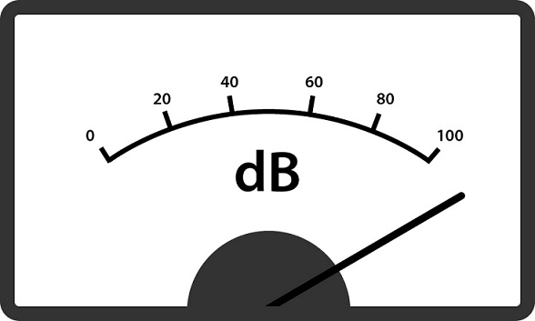

**1. NOISE BARRIERS OR SOUNDWALLS**

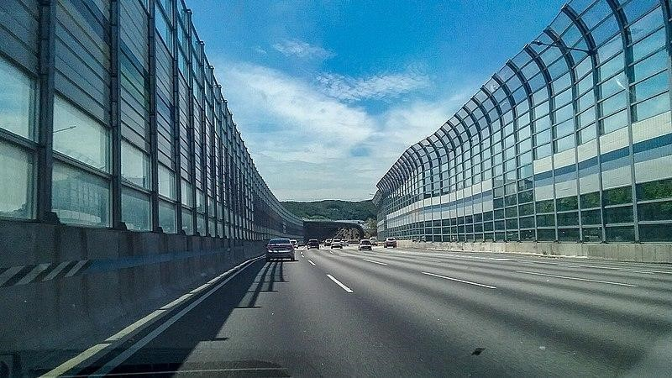

Also known as **noise walls,**these types of measures to block out high intensity traffic noise were first tested in the United States in the 1960s, and also became popular there in the 1970s with environmental laws. Noise does not only affect people, it also creates[serious problems for wildlife..](https://www.science.org/doi/10.1126/science.aah4783)

# NOISE REDUCING ROAD SURFACES

The city of Delft managed to **reduce road traffic noise by 6 dB** thanks to *quiet asphalt.* Studies that the limit for this technology is between 4 and 6 dB although limited, for urban environments it is very useful and considerably more affordable than noise barriers.

# LOWER SPEEDS

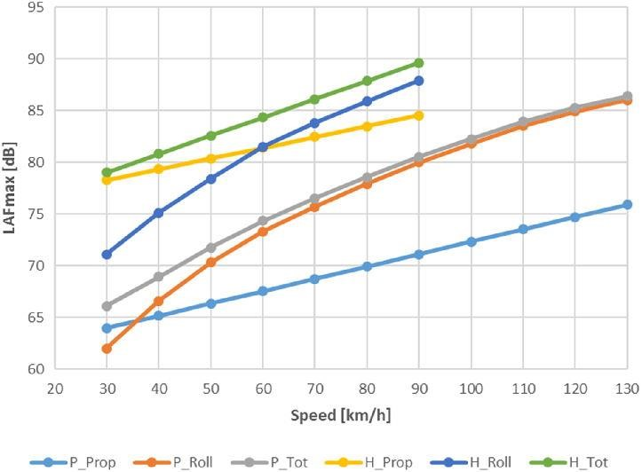

"If you can't remove motorized vehicles, the next best thing is to **reduce their speed**", according to the mobility expert Jason Slaughter in 'Cities Aren't Loud: Cars Are Loud'.

For any type of engine, greater speed means more noise, as shown in the graph. That is why often policies to reduce noise pollution (and[increase road safety)](https://tomorrow.city/a/what-is-the-evolution-use-car-city) consist in **changing infrastructures to reduce speed.** (Signs by themselves[onlyreduce a couple of km/h.](https://www.roadsafetyknowledgecentre.org.uk/downloads/20mph-reportv1.0-FINAL.pdf)

# ELECTRIC VEHICLES

[More space is also being given to electric vehicles](https://tomorrow.city/a/integrating-electric-vehicle-charging-points-into-the-urban-architecture)which, at low speeds are very quiet, however, given their volume, they can sometimes be noisier than an internal combustion vehicle at high speeds.

# VEGETATION SURROUNDING ROADS

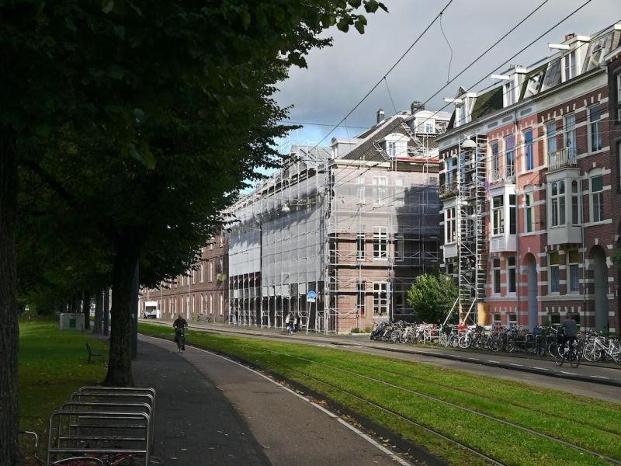

Green borders covered with plants running alongside a road are **clearly a non-tech element,** but incredibly functional. However, studies on the effectiveness of this solution, which is high, are at the forefront of technology. Very often, the best technology we can use is the oldest available to us.

# HIGH-TECH BIKES

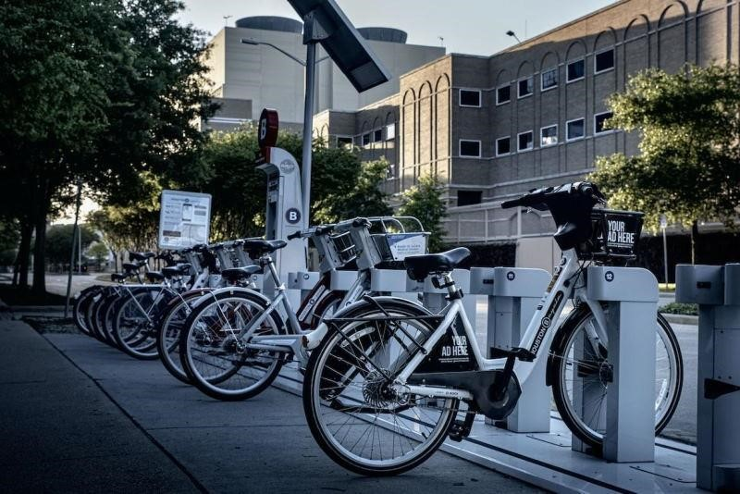

Bikes are not generally considered to be a technological element, but the way in which they are introduced in cities on a sharing basis with electric assistance, in automated docks and digitized with photovoltaic cells that charge with solar panels are high-tech indeed. And they are silent and silencing. It has been proven that bikes reduce average speeds and in turn traffic noise; and this reduces the number of vehicles.

In the urban battle against noise, all these technical, technological and scientific solutions are going to be required in order to reduce the noise thresholds to values that are not harmful to people. The mere presence of people can create noise levels that are high enough to bother residents, therefore part of the technical solutions entails **laws that focus on inappropriate or bothersome behaviors.**

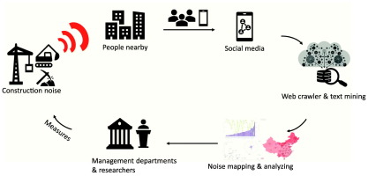

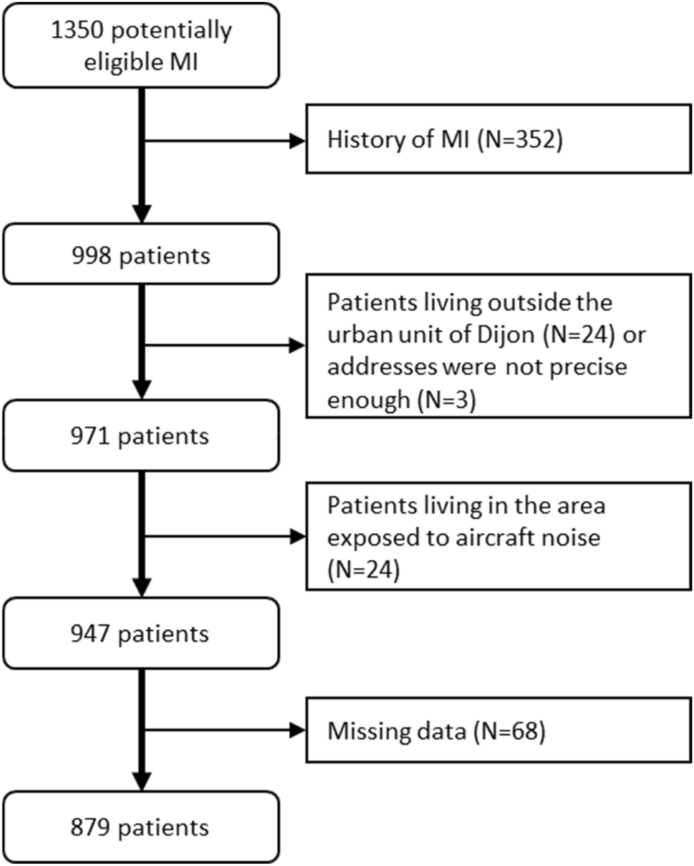

Development of Noise Monitoring Network in India

With increasing urbanization and industrialization, noise pollution

particularly in ambient is also increasing. Government of India have taken

number of steps to control noise pollution such as notifying noise rules-

2009 and prescribing noise standards for vehicles, generators sets, fire

crackers etc. Till now Maharashtra Pollution Control Board is carrying out

noise monitoring in urban area during festival periods (Diwali and Ganapati)

and ambient noise monitoring in 6 major cities of Maharashtra is being

carried out once in a year at fixed locations and the reports of these

monitoring are being displayed in the public domain through MPCB web site.

The Honourable Minister of Environment and forest has announced the

road amp of systematic monitoring of ambient noise under the National

Ambient Noise Monitoring Network Programme (NANMP) in the month of

January, 2010. As per the proposed road map 10 continuous monitoring

stations are to be established in each of seven identified cities .

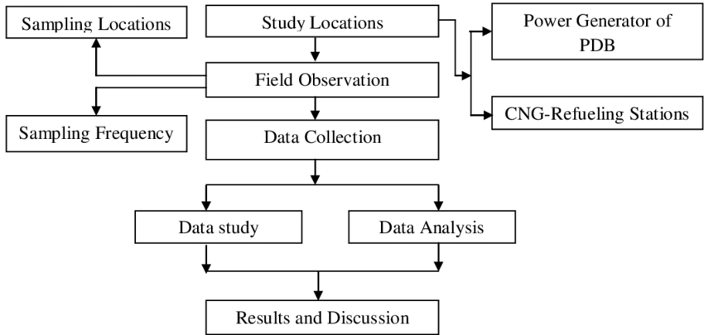

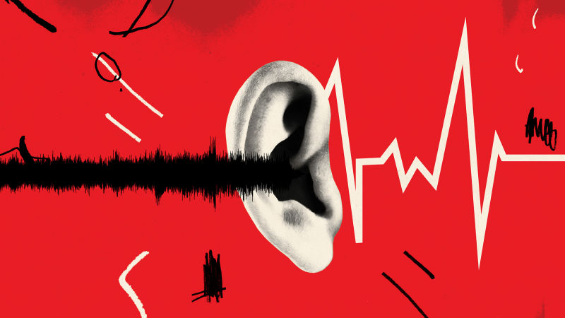

Mumbai, Delhi, Kolkata, Bangalore, Chennai, Lucknow and Hydra bad. Out of 10 stations proposed in Mumbai, 5 continuous monitoring stations have been installed at Mumbai/Navi Mumbai/Thane area at following locations: 1. Bandra, 2. Wadala, 3.Mahape (Navi Mumbai), 4. Vashi (Navi Mumbai) and 5. Thane Municipal Corporation Building (Thane). These above stations are in networking and real time noise data is being transmitted to the central server at CPCB. Glimpse of Noise Monitoring Stations

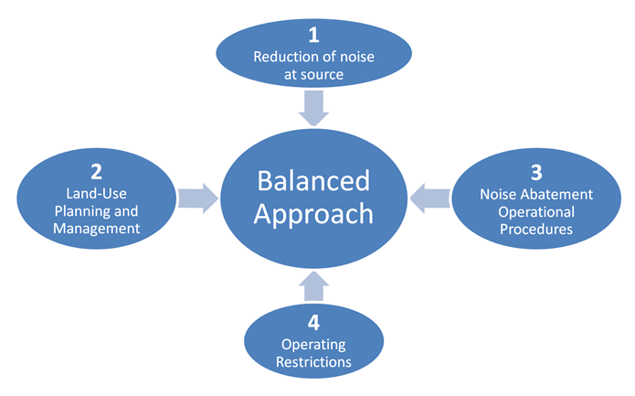

Import sounddevice as sd

Import numpy as np

Def audio_callback(indata,frames. Time,status):

If status:

Print(status,flush=True)

If np.max(indata)> 0.1: #Adjust this threshold as needed print(“Noise deleted!”)

With sd.inputstream(callbackaudio_callback):

Sd.sleep(10000) #run the program for 10 seconds

Print(“program ended.”)

